**A predictive model for Palaeolithic sites: A case study of Monforte de Lemos basin, NW Iberian Peninsula**

M. Díaz-Rodríguez, R. Fábregas-Valcarce, A. Pérez-Alberti

**Appendix SI. Supplementary information appendix with a detailed description of the obtention of each covariate used in the present study.**

1. **ALT**

The elevation map (ALT) has been obtained from the DEM (Figure 1).

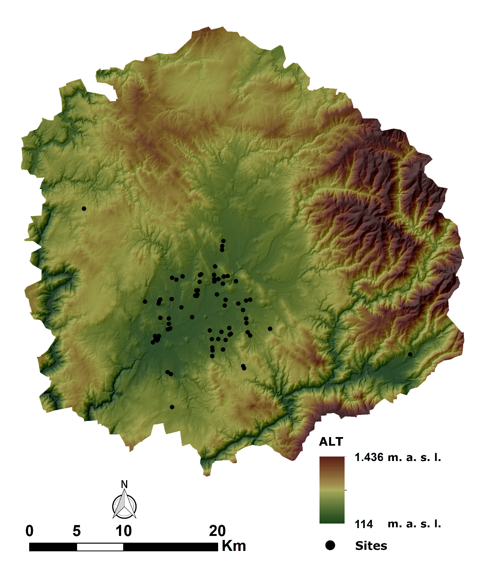

**Figure 1**. ALT covariate map.

1. **TPI100**

The TPI100 covariate has been obtained with the SAGA GIS software and from the *Topographic Position Index* tool using the DEM as a base map and establishing a 100 m radius (Figure 2).

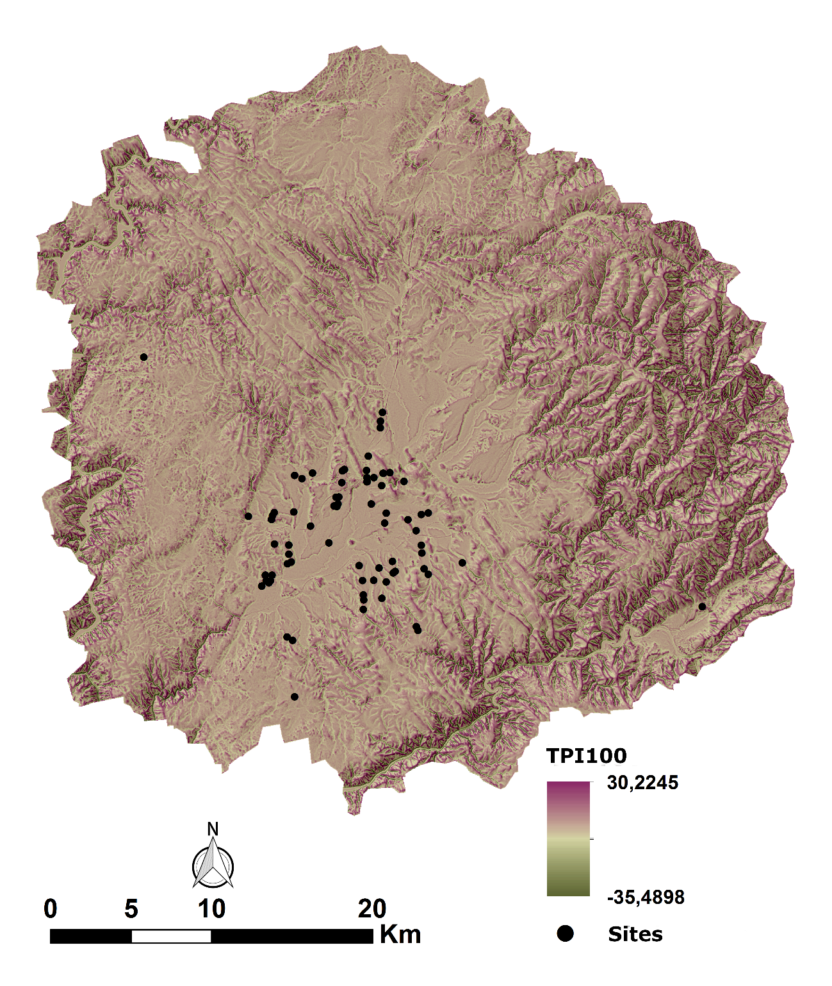

**Figure 2**. TPI100 covariate map.

1. **TPI500**

The TPI500 covariate has been obtained with the SAGA GIS software and from the *Topographic Position Index* tool using the DEM as a base map and using a radius of 500 m (Figure 3).

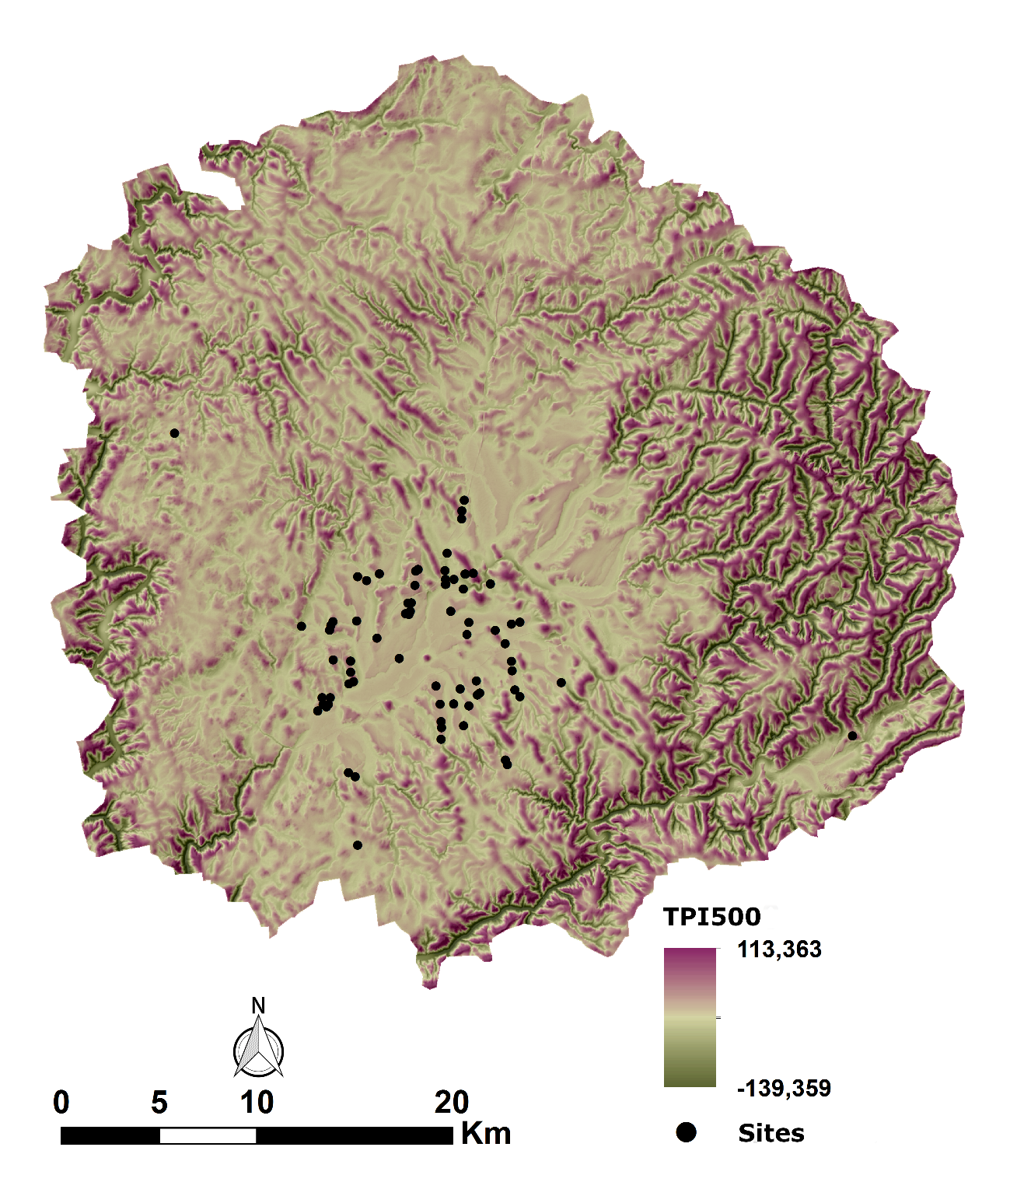

**Figure 3**. TPI500 covariate map.

1. **TPI1000**

The TPI1000 covariate has been obtained with the SAGA GIS software and from the *Topographic Position Index* tool using the DEM as a base map and employing a radius of 1000 m (Figure 4).

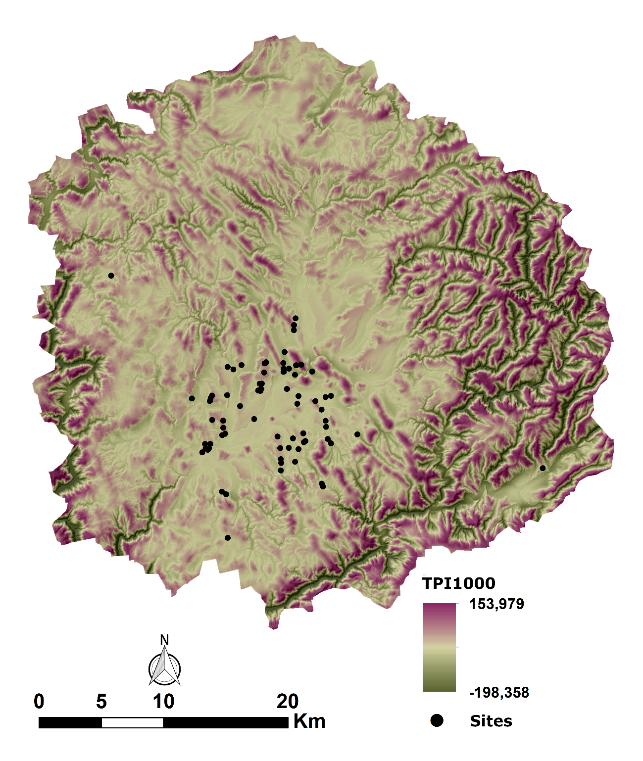

**Figure 4**. TPI1000 covariate map.

1. **SLO**

The slope covariate (SLO) was obtained from the DEM. This calculation can be done with any GIS software, but in this case, it has been carried out with the *Basic Terrain Analysis* tool from SAGA GIS. This tool allows obtaining various raster maps based on basic analysis of the terrain (Figure 5).

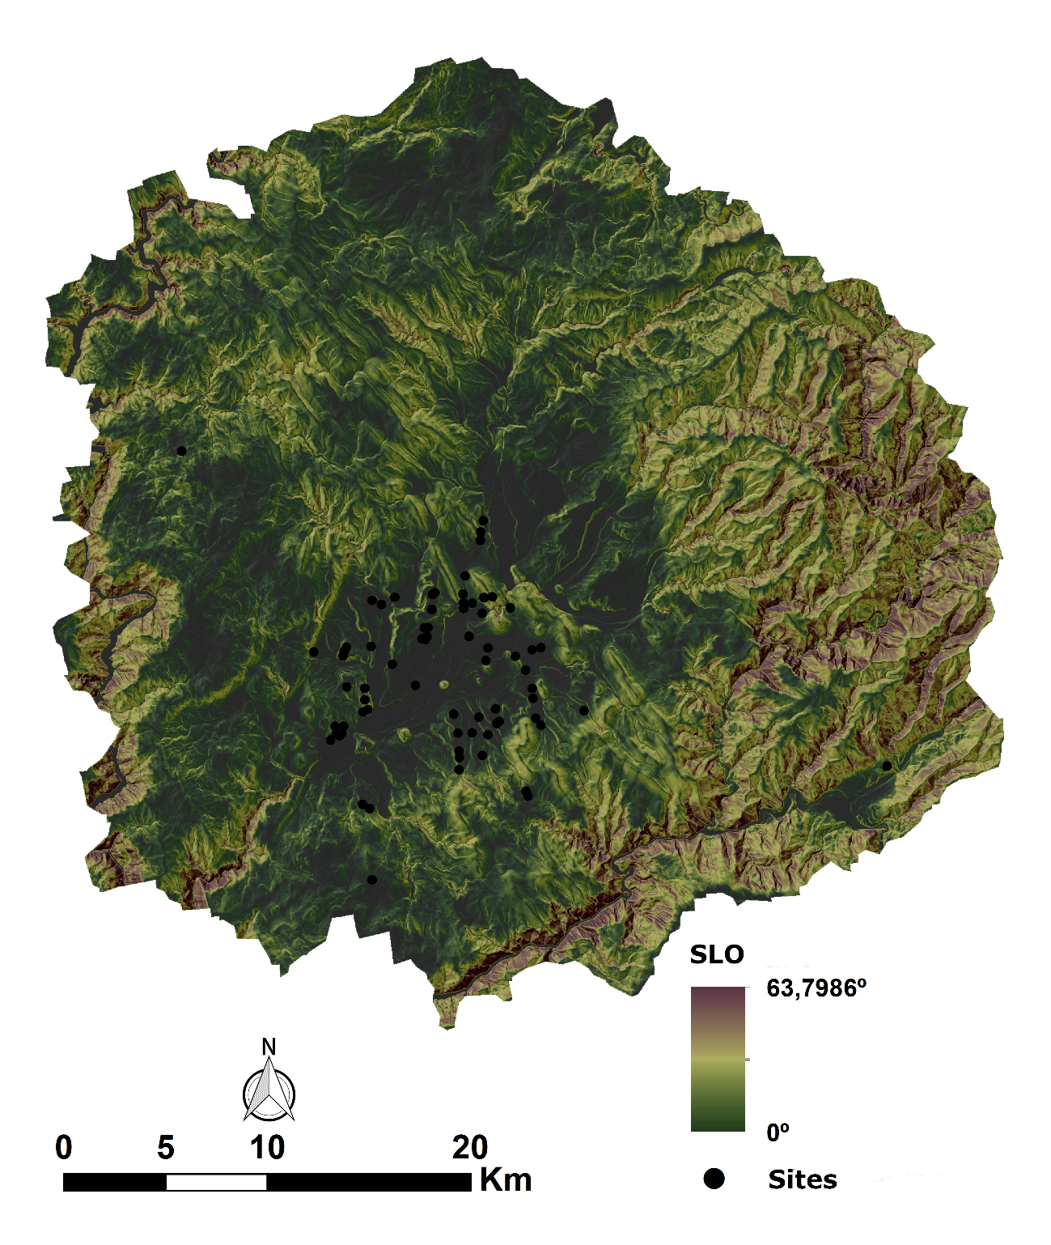

**Figure 5**. SLO covariate map.

1. **ASP**

The aspect covariate (ASP) has been obtained from the same module as the previous one: *Basic Terrain Analysis* with SAGA GIS (Figure 6).

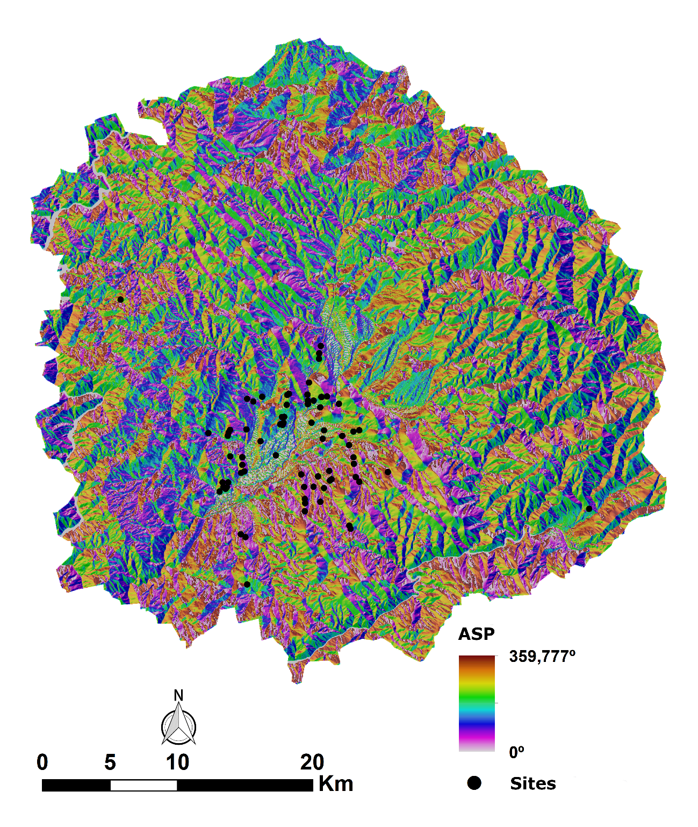

**Figure 6**. ASP covariate map.

1. **HYDROE**

We have decided to create our own hydrographic network based on the DEM and using a methodology that has been applied in previous works (García García, 2015). In order to achieve a more approximate image than the one that existed in the past. The steps carried out for the creation of the potential hydrological map are described below:

1) First, the ArcGIS software has been used to eliminate the cells called "sinks" from the model.

2) These cells can be detected with the ArcGIS *sink* tool.

3) With the *fill* tool these cells are filled.

4) The algorithm gives the cells an average value based on the neighbouring cells.

5) The *Flow Direction* tool was used, which calculates the flow direction of the hypothetical mass of water.

6) The direction that rainwater follows allows deducing the map cells that drain into another cell with the *Flow Accumulation* tool.

7) As the values obtained are very high, the *log10* function, a base 10 logarithm, has been applied with the *raster calculator* tool. The procedure of Fernández Freire (2008) was followed. It is a procedure that allows to reduce the values to a more manageable scale. In the present study it was reduced to values between 0 and 7.12.

8) The next step was to correct the pixels classified as *NoData*, which do not have values and to which the average value of the immediate cells is attributed.

9) Then a threshold was established for the drainage to lead to a watercourse. It was found that this threshold should be above 4 after reviewing the current hydrology.

10) Finally, it was decided to rank the hydrological map according to its channel based on the *Strahler method*, in which a numerical order is assigned to each river course and whose value increases whenever two courses of the same order come together. The result was a raster layer with 7 classes where the values go from 1 to 7, which represent the watercourses contained in that map.

11) To create the potential hydrology map, the channels with the highest values were used, for which the third quartile was employed and those channels with values above the third quartile were selected. Since these are water courses with a certain entity and that would have a greater survival.

12) Subsequently, the raster file was converted to a vector file to facilitate its handling.

13) To calculate the HYDROE variable, the *Euclidean Distance* tool was used, which allows measuring the distance in a straight line from potential watercourses to the rest of the map (Figure 7).

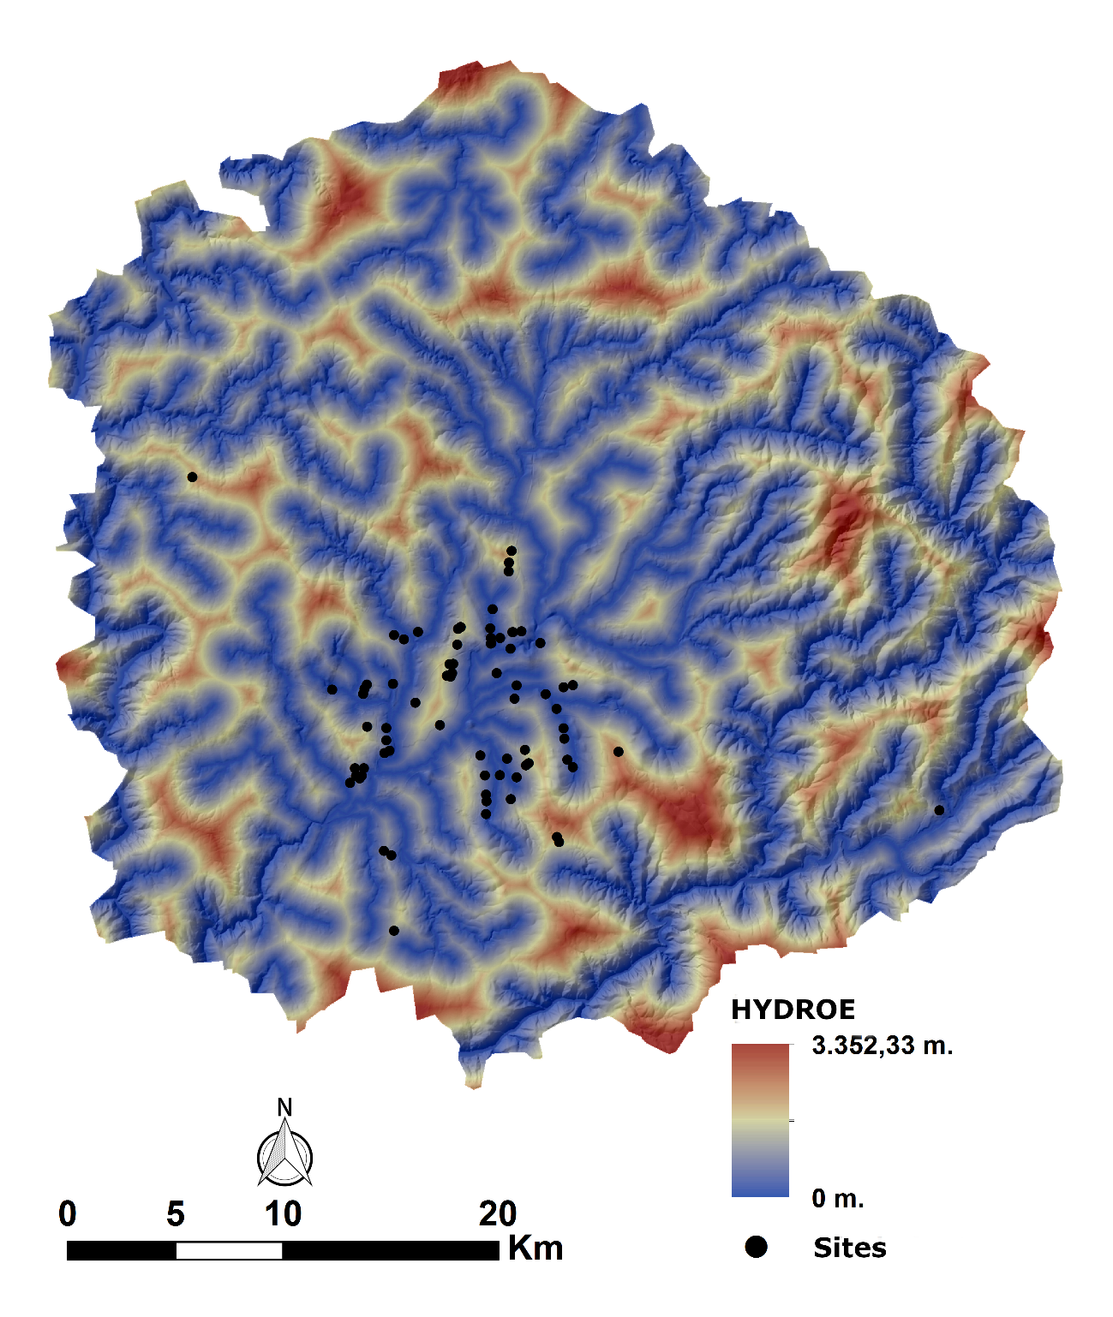

**Figure 7**. HYDROE covariate map.

1. **HYDROC**

To obtain HYDROC, the vector layer of the rivers created in the last covariate, was converted to points. This was done with GRASS GIS and the *v.to.points* tool, establishing a distance of 100 meters between each point. Subsequently, the cost of moving from those points to the rest of the map was calculated. These points were used in the tool *r.walk*, from GRASS GIS, as starting points to obtain the cost of movement in seconds using the slope and hydrology as friction layers and taking into account the movement of the knight (Figure 8).

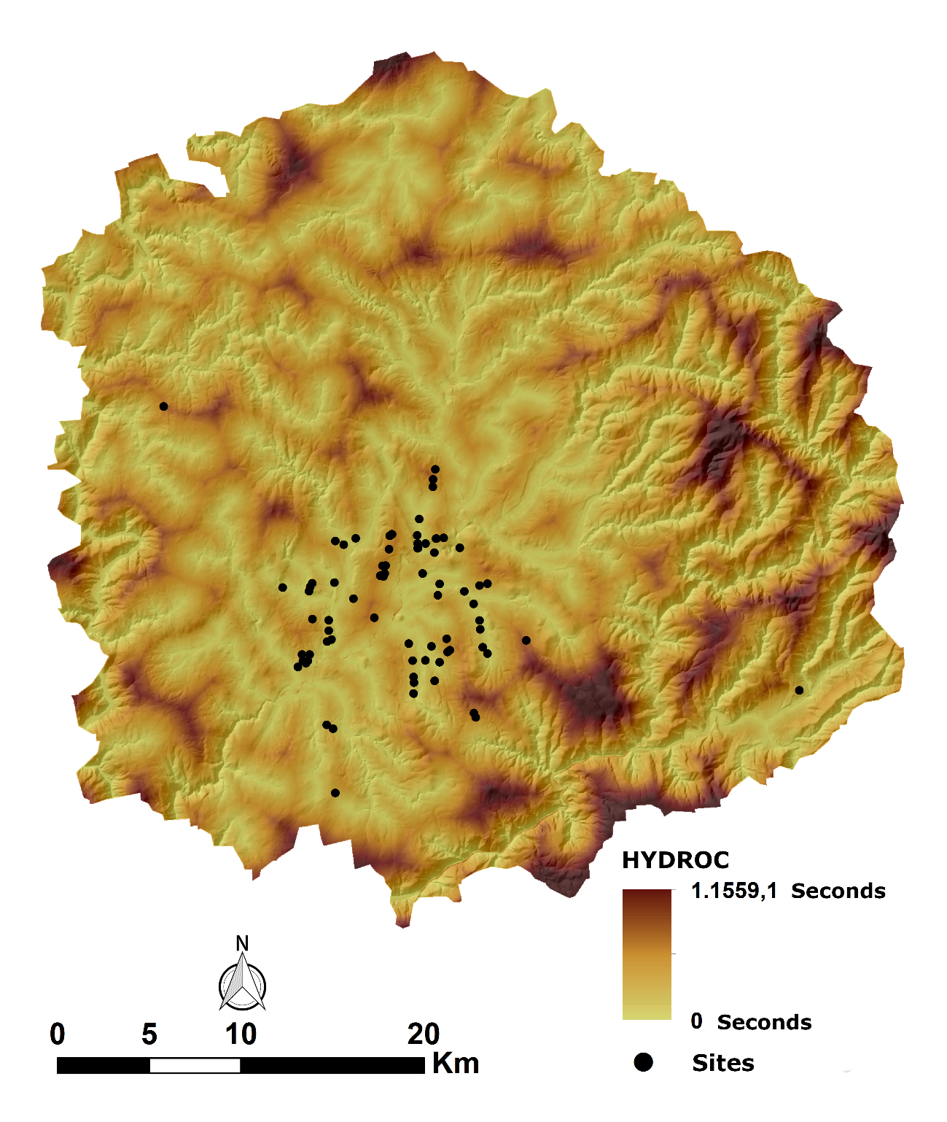

**Figure 8**. HYDROC covariate map.

1. **WET**

To calculate the potential wetland areas (WET), we use a methodology that has been developed in previous works (Böhner et al., 2001; Carrero Pazos, 2017). It consists of creating a raster map of wetlands, where the cells represent a runoff trend, in such a way that it is considered that an area with higher humidity will be more likely to become saturated and form a wetland.

1) The SAGA GIS module, *Topographic Wetness Index* (TWI), was used, which allows calculating flow accumulation based on the slope of the terrain. The result that this analysis gives us is a map that shows a humidity index for each of the cells of the map.

2) Subsequently, we decided to use, as representative, those cells that had a value greater than the third quartile, in such a way that it would be in these cells that the wetland areas would be formed.

3) Once selected the cells were converted to points.

4) The displacement cost in time was calculated from each of these points to the rest of the map cells. For this, the points previously generated in the tool *r.walk*, from GRASS GIS, were used as starting points to obtain the displacement cost in seconds using slope and hydrology as friction layers and taking into account the movement of the knight (Figure 9).

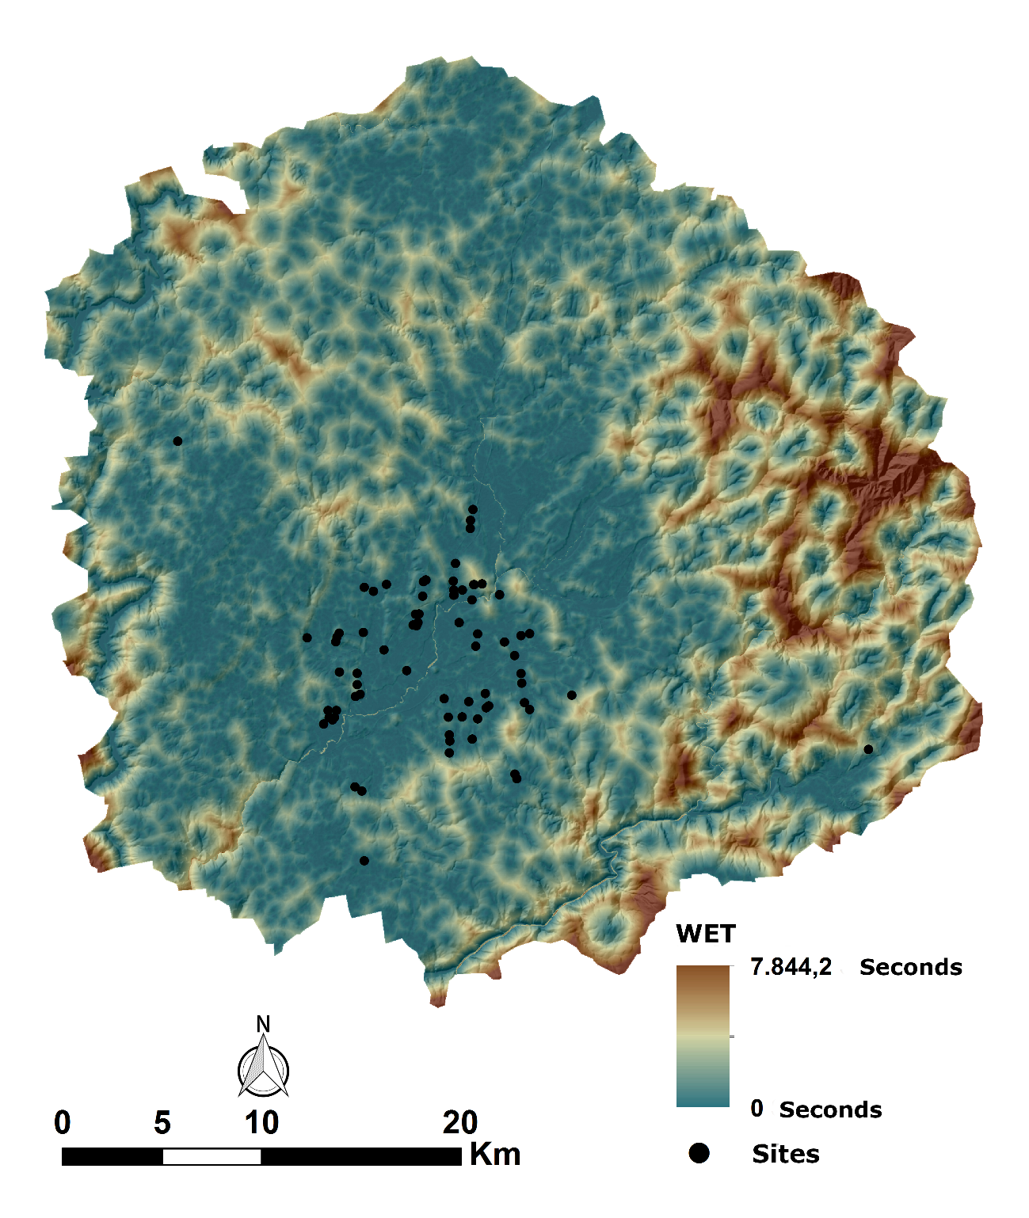

**Figure 9**. WET covariate map.

1. **GEOLE**

The process of creating the distance map to the lithological supply areas has consisted of the following steps:

1) Identify those formations likely to be exploited from the MTN geological map at a scale of 1:50,000 that could be of interest to be exploited by hunter-gatherer communities. These are the territories in which quartz, quartzite and veins of rocks used during the Palaeolithic period abound. In this specific region, areas containing Cándana quartzite, Armorican quartzite, quartz and Quaternary deposits (among others) have been selected.

2) Once those selected areas and formed by polygons were identified, the polygons were broken down into points in ArcGIS with the *Fishnet tool*, establishing regular points at 100 m away from each other.

3) From these points, the distance in a straight line from them to the rest of the map cells was calculated and thus the GEOLE covariate was obtained (Figure 10).

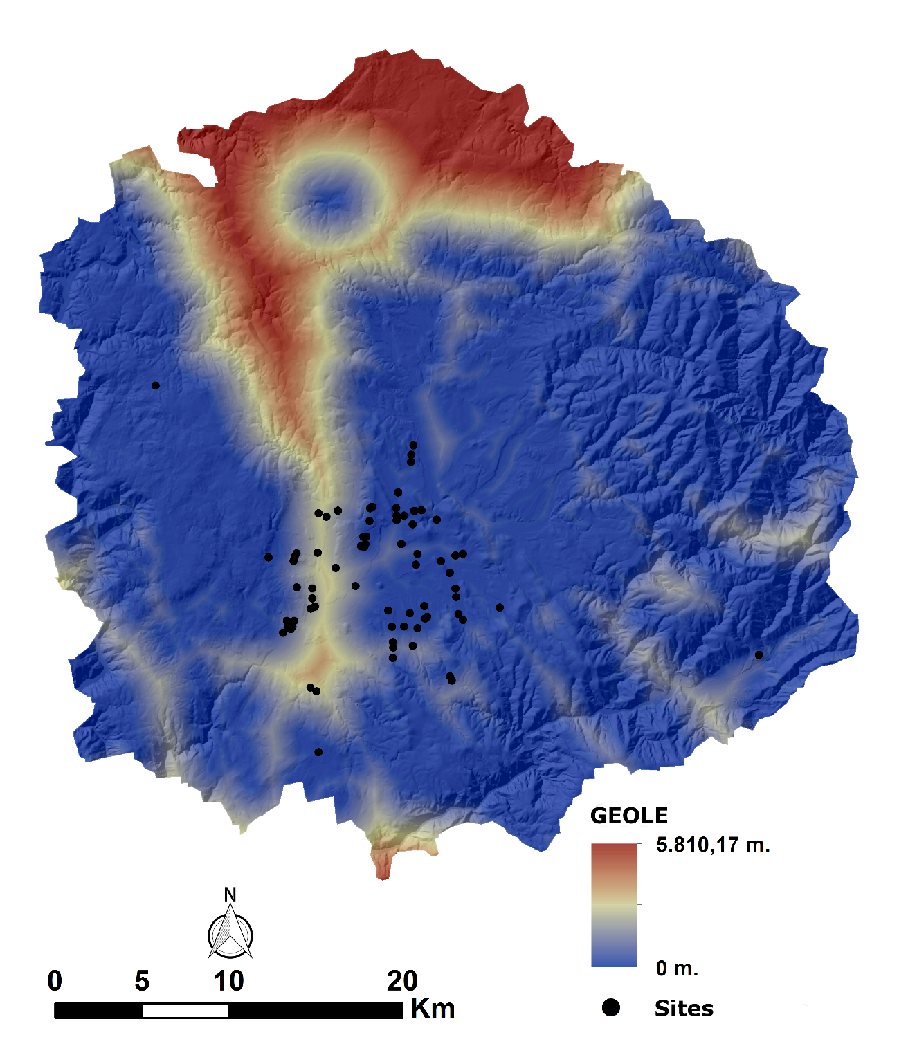

**Figure 10**. GEOLE covariate map.

1. **GEOLC**

Points based on potential geology and mentioned in the previous covariate (GEOLE) were used to calculate the GEOLC covariate. These points were employed in the GRASS GIS tool *r.walk* as starting points to obtain the cost of movement in seconds using slope and hydrology as friction layers and taking into account the knight movement (Figure 11).

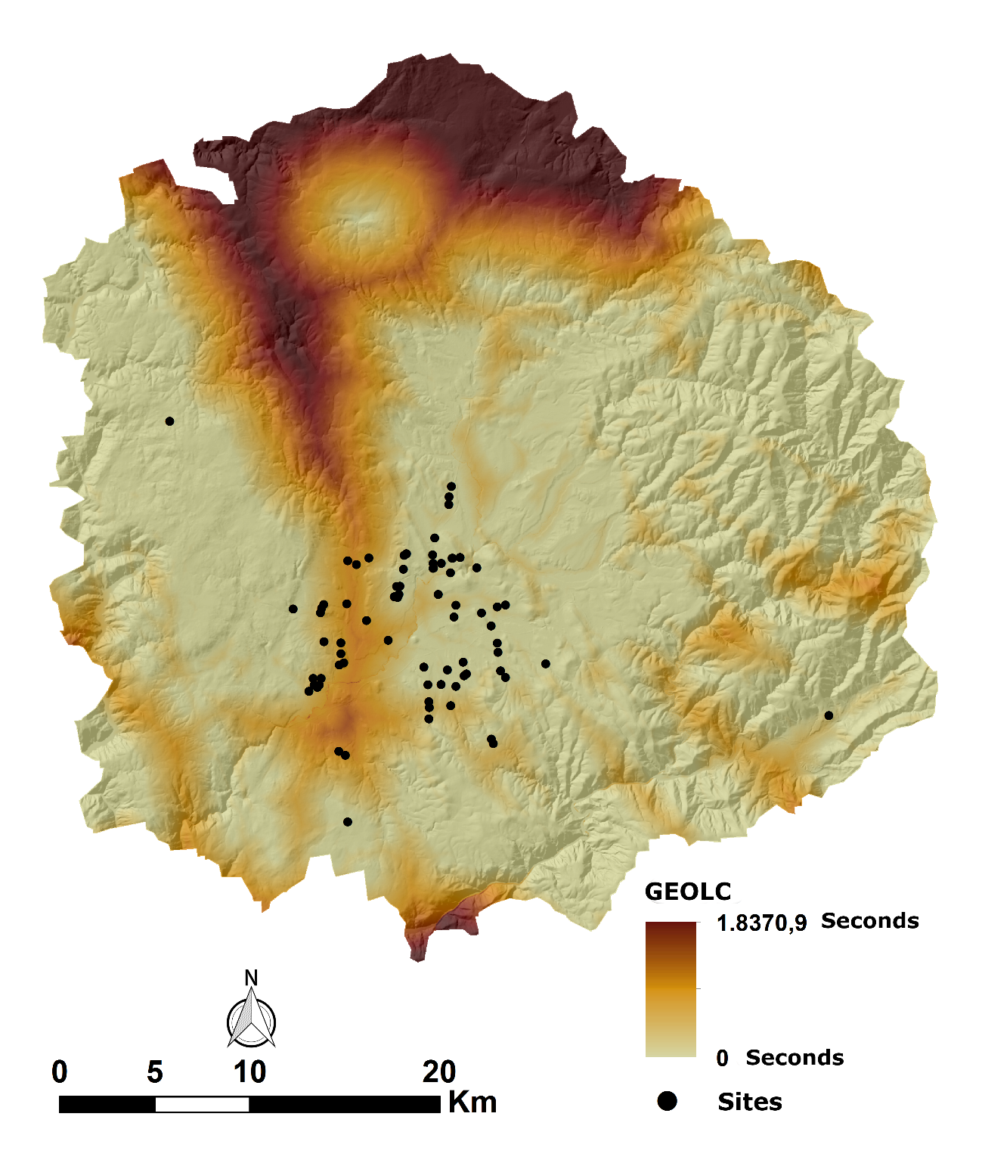

**Figure 11**. GEOLC covariate map.

1. **CPFPCG**

The Central Place Foraging Prey Choice Model is based on the calculation of travel times in a certain territory. In the present study it was applied to the hunting of goats, as one of the most representative species of the Magdalenian diet (Cannon, 2003; Marín Arroyo, 2008).

This theory was used to estimate the maximum limit of productivity associated with that species. Thus, taking into account a point of origin, the maximum hunting distance for different animals should be related to the energy associated with each of them and the costs of their processing and transportation (Cannon, 2003). As a result, a maximum travel time was established, so that the capture of the goat supposes the highest possible productivity, of 1.2 hours. On the other hand, within that catchment area it is necessary to establish the surface in which a certain species can live, considering its ecological characteristics. In the absence of more precise environmental data corresponding to that period, it was considered that the slope would be the most determining factor when establishing the areas potentially exploitable by animals from rocky habitats (such as the goat), since the altitude or the solar exposure present a range of validity for each species that is not very limiting. Depending on the slope, it was established that the species associated with mountain habitats would be located above a 30º slope, and those associated with flat areas would be below a 30º slope (Marín Arroyo, 2008).

1) To assess the goat catchment area, the Monforte de Lemos basin sites layer was used as source points. Isochrons of 1.2 hours from each site were considered.

2) Once these areas were delimited, the cells with a slope greater than 30º were identified.

3) Subsequently, each of these cells was converted to a point.

4) The cost of moving from those selected points to the rest of the map cells was calculated with the *r.walk* tool, from GRASS GIS, using slope and hydrology as friction layers and taking into account the knight movement (Figure 12).

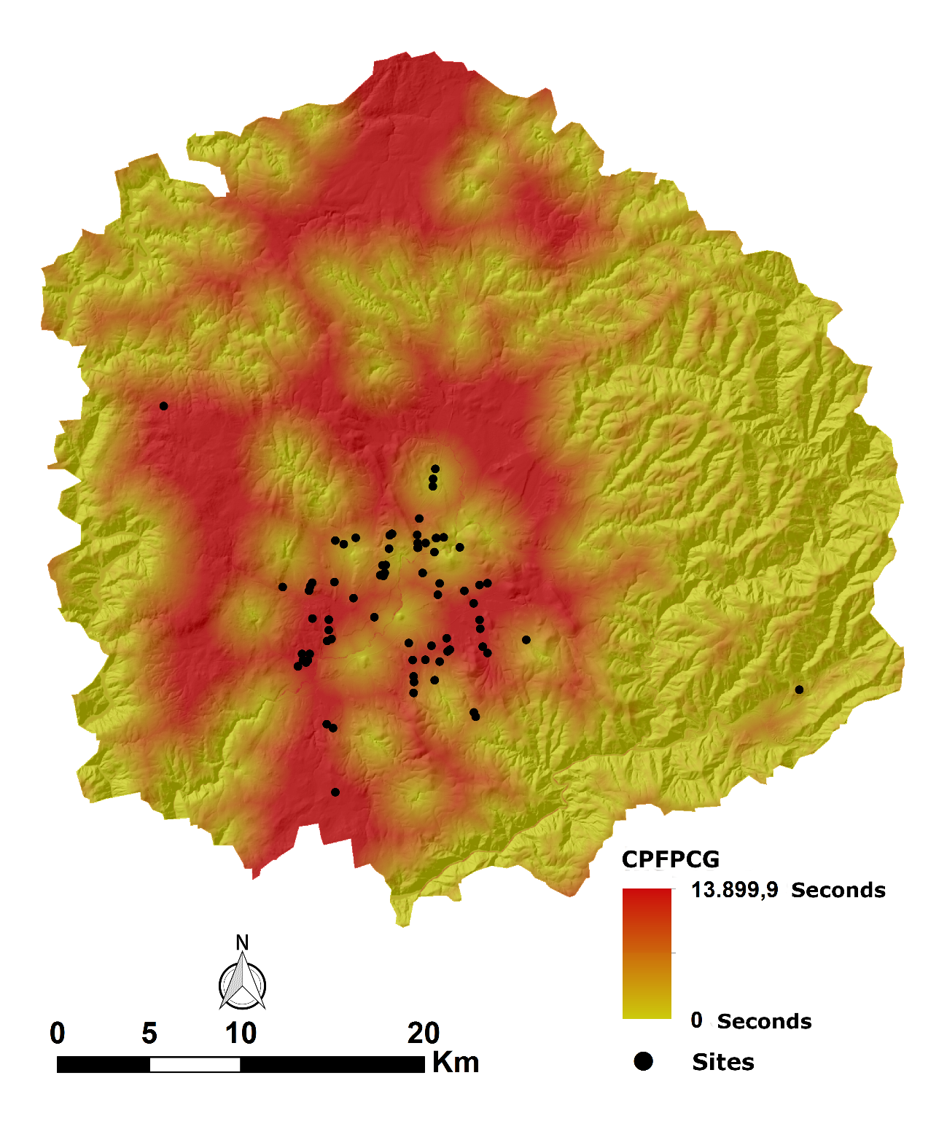

**Figure 12**. CPFPCG covariate map.

1. **VISPR**

To create the VISPR covariate, the following steps were followed:

1) Points are created regularly distributed with the ArcGIS *fishnet* tool and at 500 m between each point.

2) Then the layer of points is cut with the polygon of the study area with the *clip* tool.

3) In the next step three columns are created OFFSETA (with value 0), OFFSETB (with value 1.75) and RADIUS 2 (with value 5000). Those data are respectively related to the observer height, the target height and the maximum observation distance. In the case that concerns us, it is important to reverse the positions of the observer and the objective to achieve the desired result. Where it is intended to reproduce a total visibility where each cell records the number of other map cells that are visible from it, adding the visibilities of each possible point of view (Conolly and Lake, 2006).

4) Finally, the *viewshed* tool was used from the point layer mentioned above and taking into account the established criteria (Figure 13).

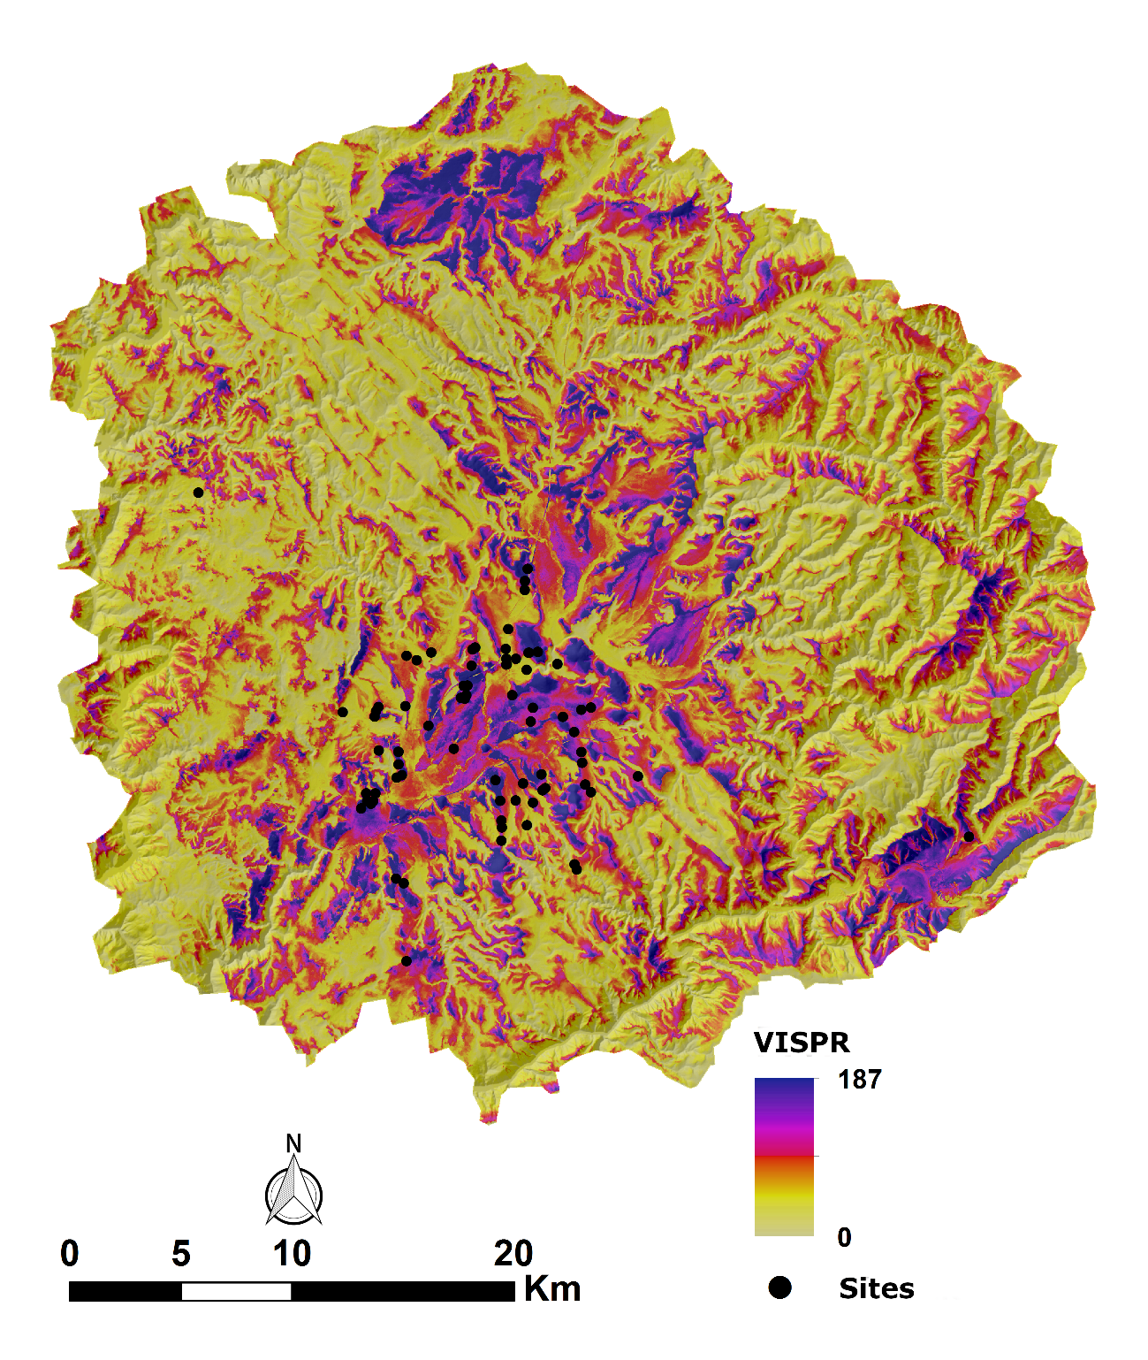

**Figure 13**. VISPR covariate map.

1. **LCPC**

For the obtention of the LCPC covariate (Figure 14), we have chosen a methodology that is as neutral as possible, without considering the location of the archaeological sites when defining the starting and destination points. This is because we are not interested in the path relationship between the different sites, but rather we intend to observe the relationship of proximity to those potential transit routes.

To carry out the modelling of potential transit, we take as a starting point the model called FETE (From Everywhere to Everywhere) (White and Barber, 2012), which calculates the potential transit routes between all possible locations in the delimited area. In technical terms, this study used an analysis where all the points of a grid acts as starting points and in turn as arrival points, in such a way that the calculation allows representing the entire territory, creating the least cost routes for the entire chosen area. However, this analysis requires very powerful computer equipment to which we do not have access. For this reason, we decided to adapt and simplify this model following the methodology employed in other works (Díaz Rodríguez, 2017; Rodríguez Rellán and Fábregas Valcarce, 2015).

To obtain the map of this covariate (Figure 14), the following steps were followed:

1) Points separated by 2000 m from each other and located along the contour of the study area have been generated.

2) From each of these points, the least cost path to the remaining points was sought. To calculate the cost we considered, as a friction surface, the hydrological accumulation and the slope. All this process was carried out in GRASS GIS.

3) Accumulation was calculated with *r.watershed* and the DEM was used to account for slope.

4) In the next step, the displacement cost of each one of the points to the rest was obtained, incorporating the reclassified and adapted accumulation map and the DEM into the *r.walk* tool. In addition, the knight movement was considered, which results in a slower but more precise displacement.

5) This process was repeated for each of the points created. Once each of the layers was obtained, *r.drain* was extracted to, in this way, generate the routes with the least transit cost.

6) Finally, the created routes were converted into points with the *v.to.points* tool, points were created at about 100 m of distance between them and the cost of travel from each of these points to the rest of the study area was calculated, which we had already used in other previous calculations.

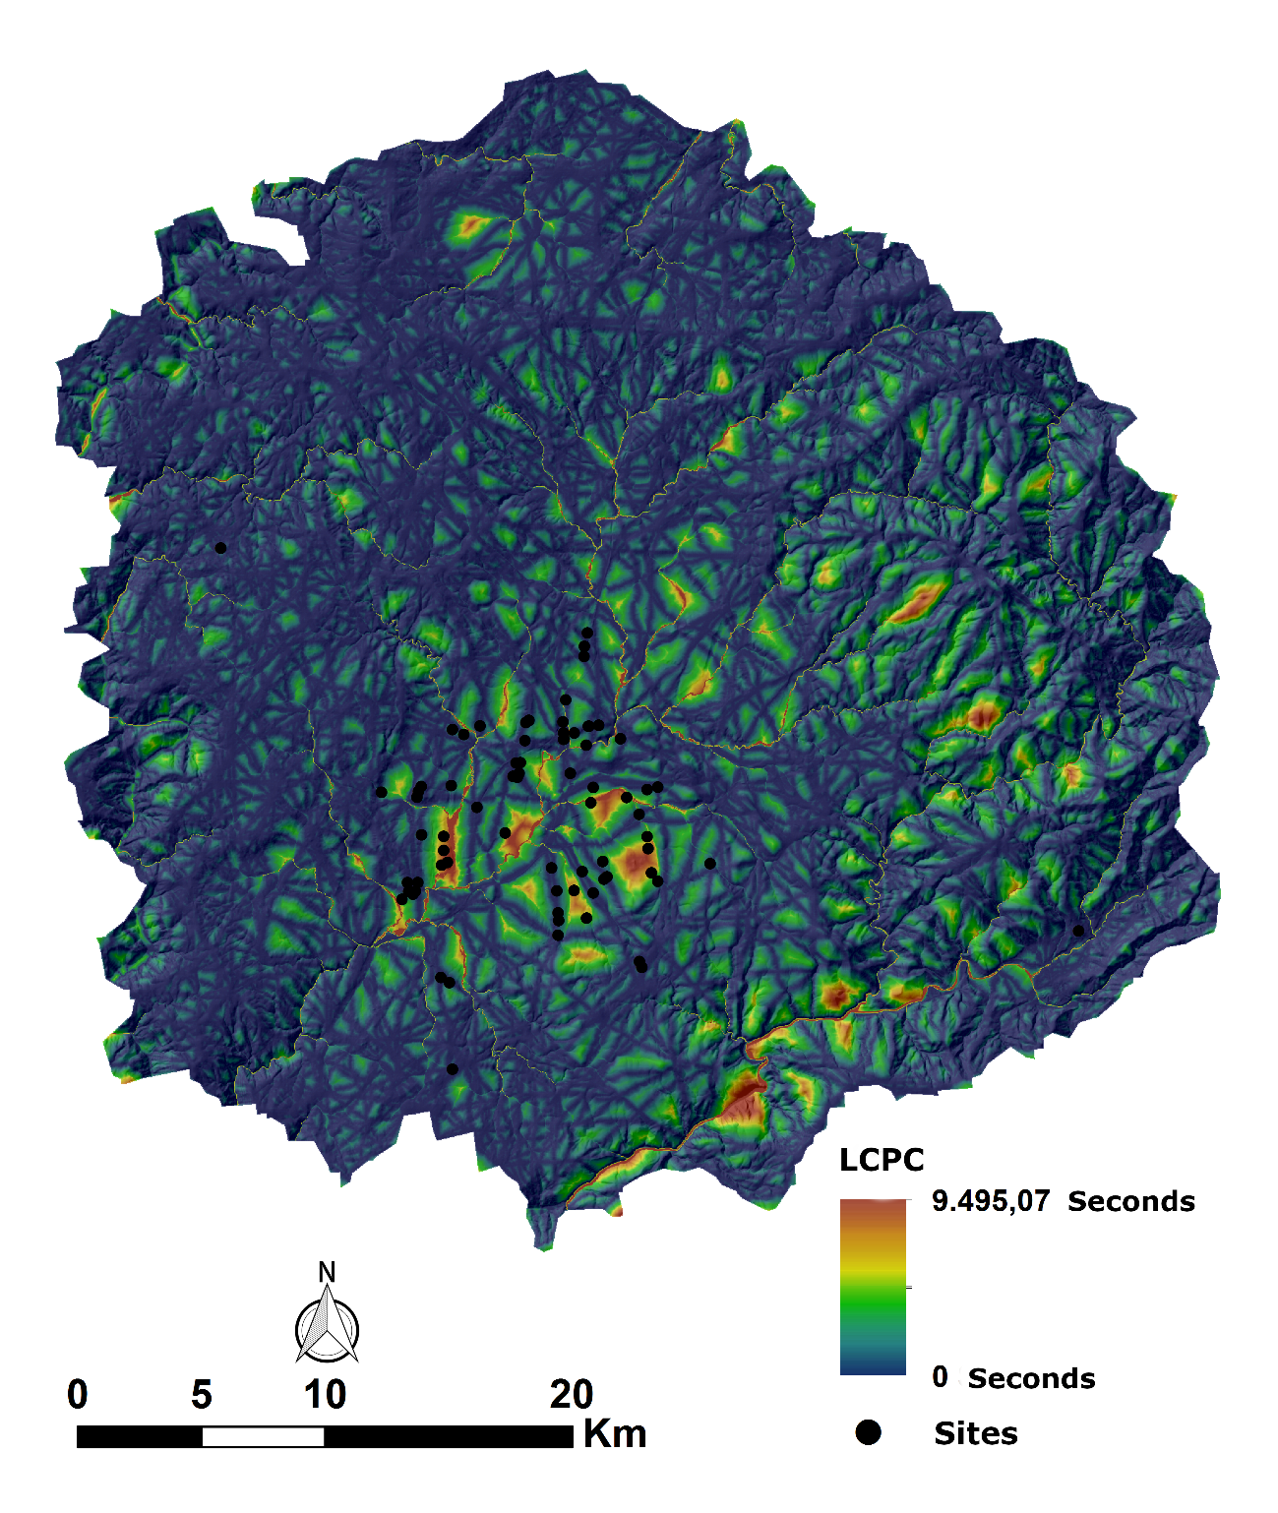

**Figure 14**. LCPC covariate map.

1. **DIRINS**

The DIRINS covariate (Figure 15) was calculated with SAGA GIS, from the *Potential Incoming Solar Radiation* module (Conrad et al., 2015).

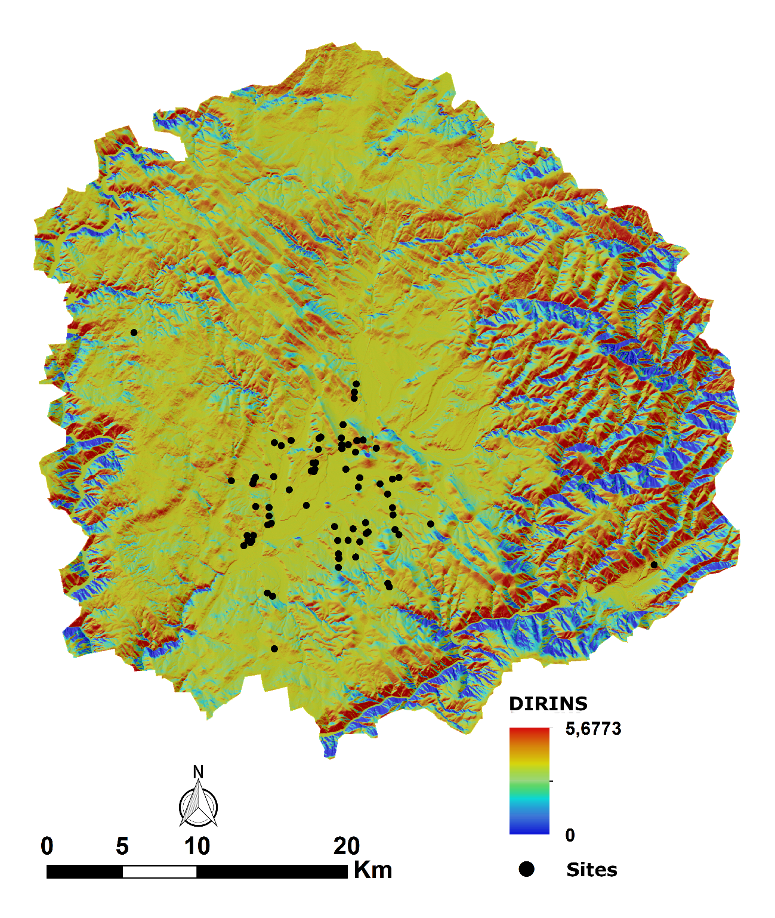

**Figure 15**. DIRINS covariate map.

1. **DIFINS**

The DIFINS covariate (Figure 15) was calculated with SAGA GIS, from the *Potential Incoming Solar Radiation* module (Conrad et al., 2015).

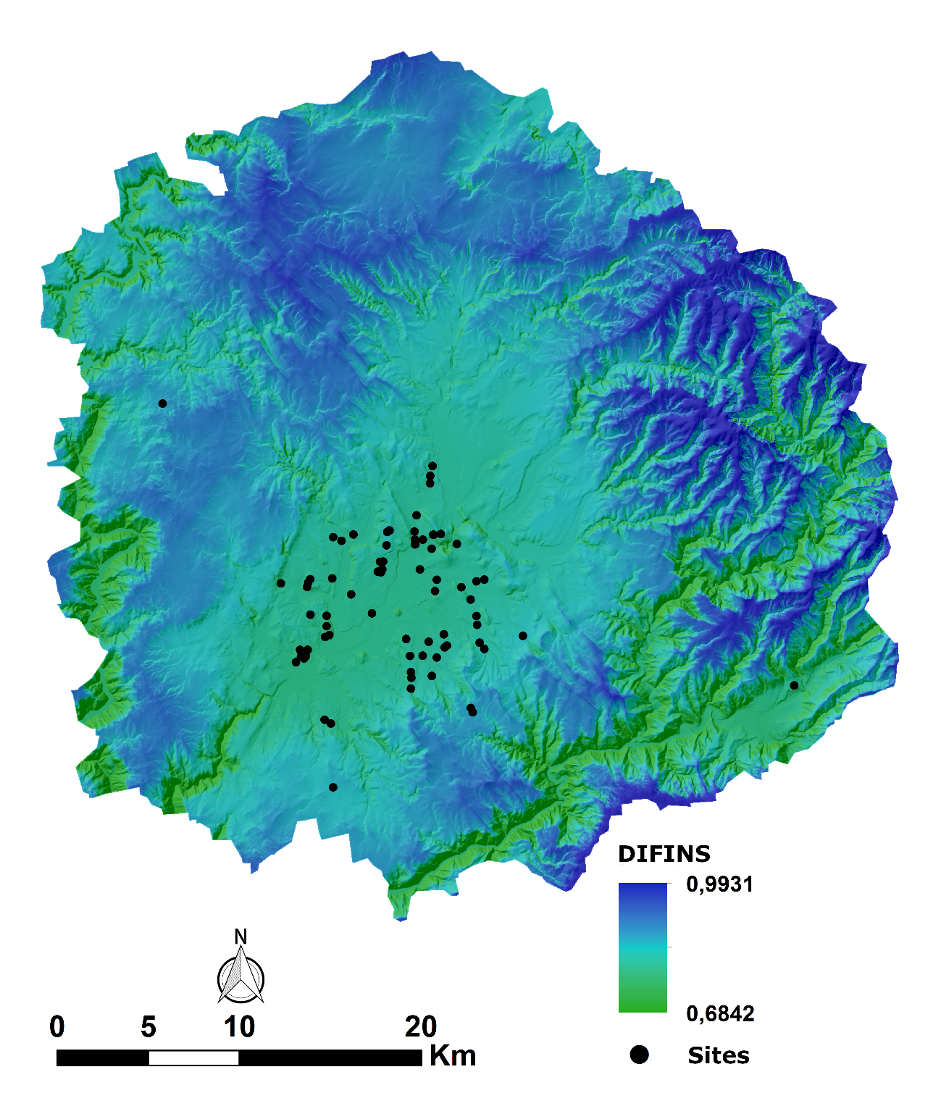

**Figure 16**. DIFINS covariate map.

1. **TOTINS**

The TOTINS covariate (Figure 17) was calculated with SAGA GIS, from the *Potential Incoming Solar Radiation* module (Conrad et al., 2015).

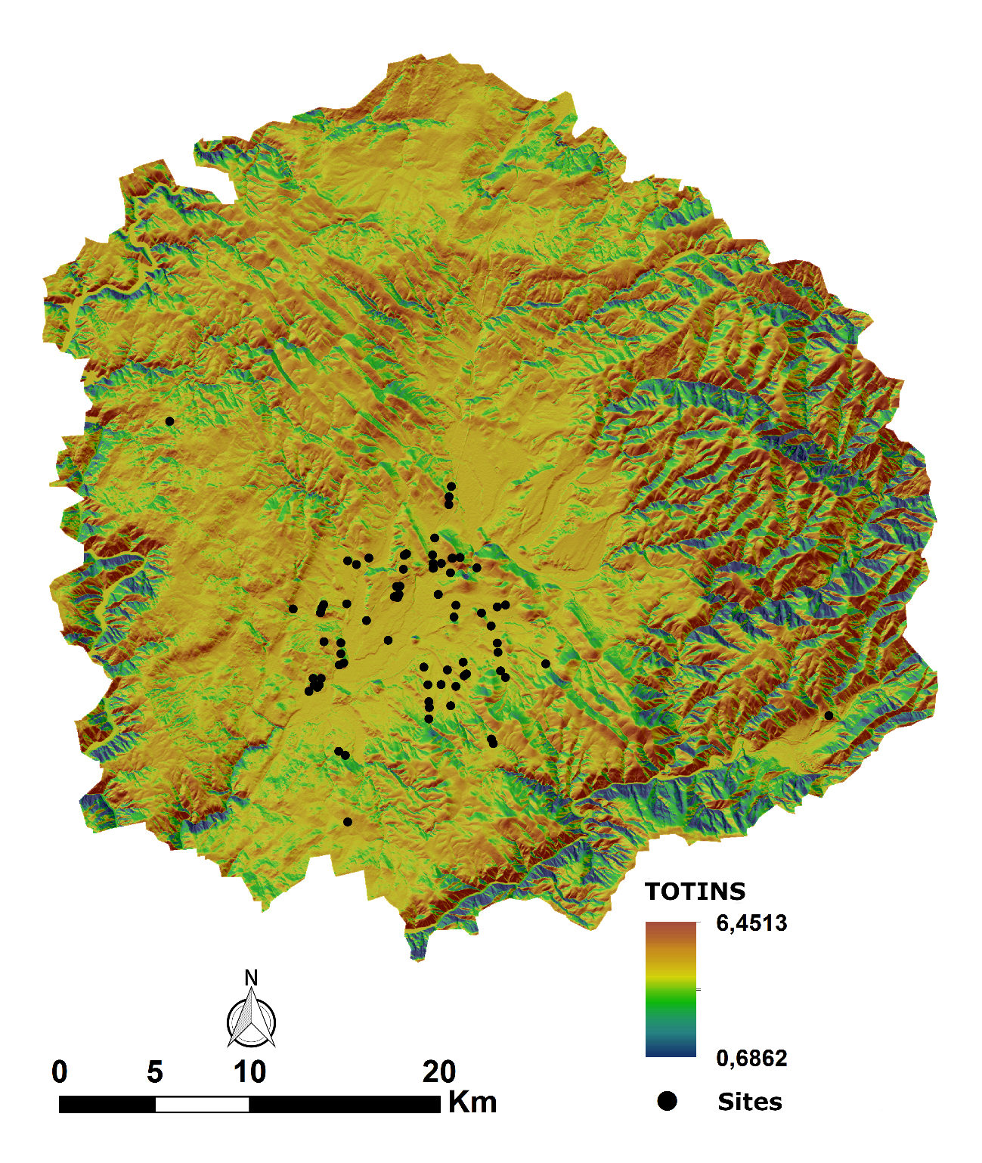

**Figure 17**. TOTINS covariate map.

1. **WIND**

The WIND covariate it was obtained from the calculation of the *Wind Exposition Index* through the *Wind Effect Index* of the SAGA GIS software (Böhner and Antonić, 2009; Conrad et al., 2015).

**References**

Böhner, J., Antonić, O., 2009. Land-Surface Parameters Specific to Topo-Climatology, in: Hengl, T., Reuter, H.I. (Eds.), Geomorphometry: Concepts, Software, Applications. Elsevier, Amsterdam (The Netherlands), pp. 195–226. https://doi.org/10.1016/S0166-2481(08)00008-1.

Böhner, J., Köthe, R., Conrad, O., Gross, J., Ringeler, A., Selige, T., 2001. Soil regionalisation by means of terrain analysis and process parameterisation, in: Soil Classification. Luxemburgo, pp. 213–222.

Cannon, M.D., 2003. A model of central place forager prey choice and an application to faunal remains from the Mimbres Valley, New Mexico. J. Anthropol. Archaeol. 22, 1–25. https://doi.org/10.1016/S0278-4165(03)00002-3

Carrero Pazos, M., 2017. El Fenómeno tumular y megalítico en Galicia. Aportaciones desde los Sistemas de Información Geográfica y la estadística espacial para el estudio de los patrones de localización. Tomo II. Universidade de Santiago de Compostela.

Conolly, J., Lake, M.W., 2006. Geographical Information Systems in Archaeology. Cambridge University Press, Cambridge.

Conrad, O., Bechtel, B., Bock, M., Dietrich, H., Fischer, E., Gerlitz, L., Wehberg, J., Wichmann, V., Böhner, J., 2015. System for Automated Geoscientific Analyses (SAGA) v.2.1.4. Geosci. Model Dev. 1991–2007. https://doi.org/10.5194/gmd-8-1991-2015

Díaz Rodríguez, M., 2017. Patrones de asentamiento en el Paleolítico superior y el Epipaleolítico en el Noroeste Peninsular. Cálculo de rutas óptimas y movilidad, in: Vázquez Martínez, A., Cordeiro Macenlle, R., Carrero Pazos, M., Díaz Rodríguez, M., Rodríguez Nóvoa, A.A., Vilas Estévez, B. (Eds.), (Re)Escribindo a Historia. Achegas Dos Novos Investigadores En Arqueoloxía e Ciencias Da Antigüidade. Santiago de Compostela (A Coruña), pp. 25–46.

Fernández Freire, C., 2008. Pisajes agrarios pre y protohistóricos en la comarca de la Vera Alta (Cáceres): un enfoque arqueo-geográfico. Universidad Complutense de Madrid. https://doi.org/ISBN: 978-84-693-1123-3

García García, M., 2015. Poblamiento y sociedad en el valle medio del Duero durante la edad de los metales (ca. 2800-450 cal. ANE). Un estudio de arqueología del paisaje. Universidad de Valladolid.

Marín Arroyo, A.B., 2008. Patrones de movilidad y control del territorio en el Cantábrico oriental durante el Tardiglaciar. Trab. Prehist. 65, 29–45.

Rodríguez Rellán, C., Fábregas Valcarce, R., 2015. Arte rupestre galaica: unha achega dende a estatística espacial e os SIX. Semata. Ciencias Sociais e Humanidades 27, 9–34.

White, D.A., Barber, S.B., 2012. Geospatial modeling of pedestrian transportation networks: A case study from precolumbian Oaxaca, Mexico. J. Archaeol. Sci. 39, 2684–2696. https://doi.org/10.1016/j.jas.2012.04.017